# Lab 04: Dataflow Gen 2 in action

### 

### Introduction

In this lab, you will use Dataflow Gen2 to execute some advanced Data Preparation activities. You will first consume a complex JSON file with 2 methods, then you will extract and transform data from an Open Data environment based on REST API.

### Objectives

After completing this lab, you will be better able to:

1. Import and Transform Data from a complex data structure
2. Understand how to implement advanced M code
3. Import and Transform Data from a REST API call

**Estimated time to complete this lab**

60 minutes

Contents

Lab 04: Dataflow Gen 2 in action 1

Introduction 1

Objectives 1

Task 1: Import and Transform Data from a complex data structure 3

Task 2: Execute advanced M code 14

Task 3: Extract data from OData 19

**Lab Prerequisites**

* Workspace: Fabric, Power Premium or Fabric trial
* Individual license: Power Pro or Premium Per User account

**Information provided by your training provider**

* Trial tenant (if applicable): login & password, workspace to use for the lab.
* Azure Data Lake Gen2 (containing data sources): account name & shared access signature.

### Task 1: Import and Transform Data from a complex data structure

In this task, you will import data from a JSON file then manipulate the structure before loading it to the Lakehouse.

The file to be loaded is name **Contoso.json** and is stored in the labdate/json folder from the Azure Data Lake Store Gen 2 account used in the previous labs.

This file contains a list of contacts, with several attributes (age, gender…) and some multiple value attributes (tags, friends).

Create a **Dataflow Gen2** artifact in your workspace.

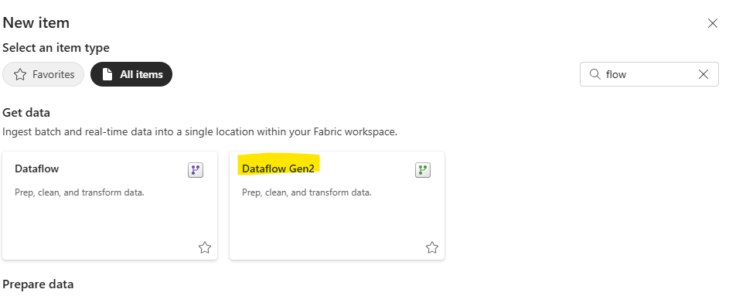

Go to the **Get Data** Menu and click on **More.**

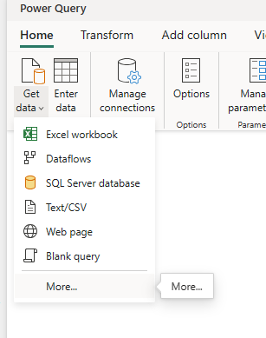

On the Choose data source window, type **Azure Data Lake** and select **Azure Data Lake Storage Gen2.**

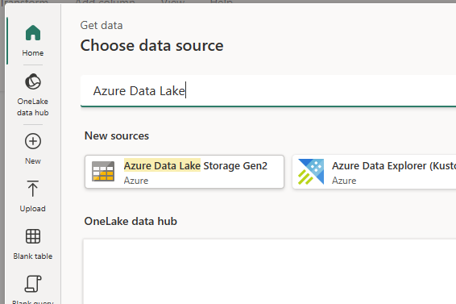

Configure the connection to the Contoso json file stored in the ADLS Gen2 account using a Shared Access Signature.

* **URL**: https://<storage account>.dfs.core.windows.net/labdata/json/Contoso.json
* **Authentication kind**: Shared Access Signature (SAS)
* **SAS Token**: value token provided by your trainer

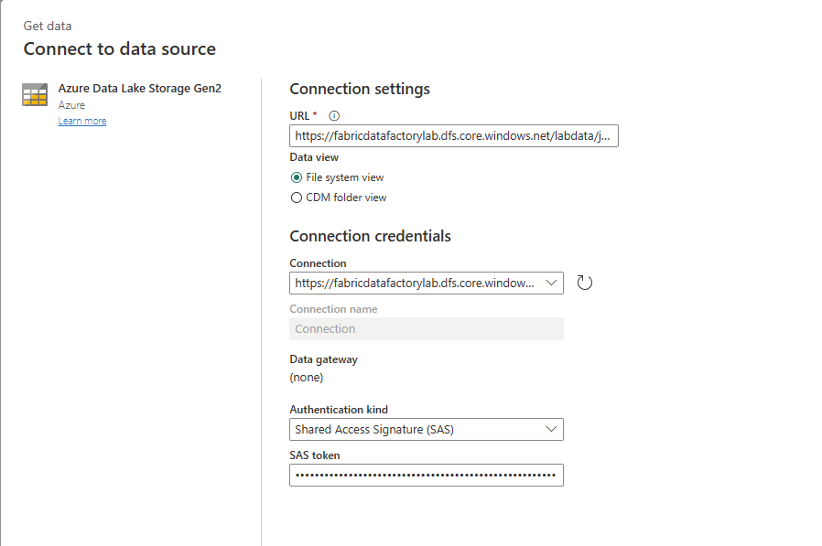

Click on **Create** to edit the query and extract data from the Contoso.json file.

Rename the query named “Query” as “Contacts” in the Queries panel, and click on the icon in the **Content** column header to ask the Dataflow Gen2 to explorer and extract the data from JSON file.



The Dataflow engine will automatically analyze the file structure and display the query result.

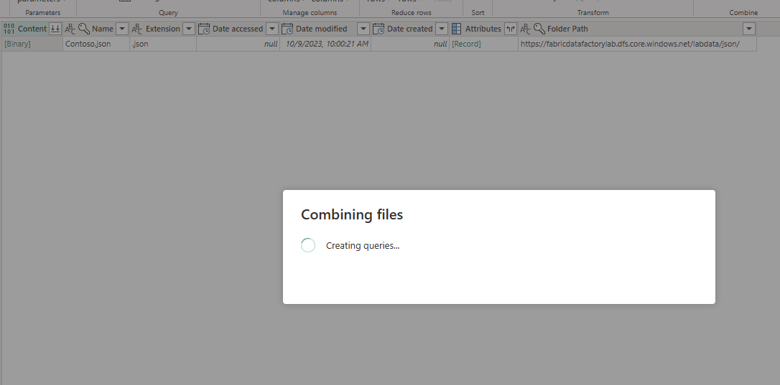

The query result is displayed on the Data Grid, and collection of resources have been automatically added.

Select the **Contacts** query and clone it to create the new query **ContactTags** (to clone a query, right click, and select “Duplicate”).

Select the **Contacts** query, and as indicated in the screenshot hereafter, select the following group of columns: age, eyeColor, name, gender, company, email and phone. Keep the selection active, right on the columns header and select **Remove other columns**.

The **Contacts** query should only contain the selected columns.

Repeat the same operation for the **ContactTags** query, to keep the following columns: name and tags.

Then click on the small button located on the **tags** column header to expand the column values (which is a list).

As the **ContactTags** query has been expanded, the same name appears who each corresponding tag value.

Click on the + icon in the **Data destination** area and select **Lakehouse**.

Keep the default configuration and click **Next**.

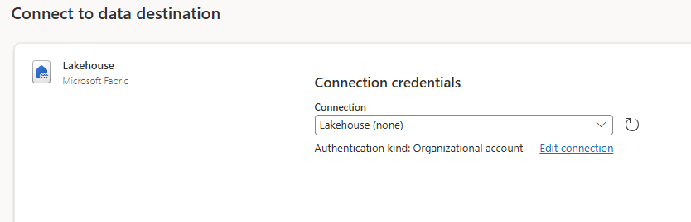

Select the existing **Contoso** lakehouse located in the same workspace, keep the destination table name as **ContactTags**, and click on **Next**.

Disable the “Use Automatic Settings” option, and configure the mapping as indicated hereafter, and click on **Save settings**.

Repeat the same operation for the **Contacts** query to load data in the **Contoso** Lakehouse using **Contacts** as the destination table name.

Click on **Diagram view** to see graphically how the 2 queries are structured.

The **Contacts** query display the Lakehouse icon displaying where and how the data will be loaded.

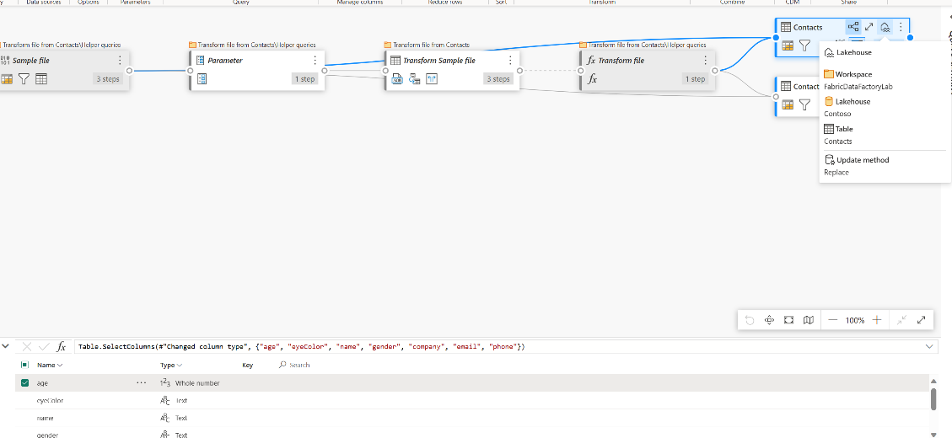

Expand the **Contacts** query to display the sequence of transformation step.

Click on **Publish** to save the Dataflow definition and start its first execution.

Wait until the end of the first Dataflow execution, by monitoring the column **Refreshed.**

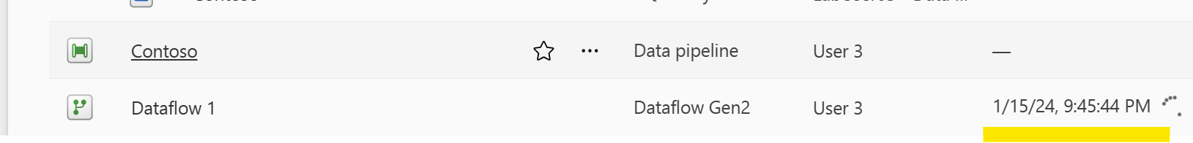

When the dataflow has been successfully executed, click on the Dataflow and select **Properties.**

Rename the dataflow as **ContactsLoading.**

Open the Contoso Lakehouse, and open the 2 tables Contacts and ContactTags, to make sure they contain data loaded from the CSV file.

### Task 2: Execute advanced M code

In this task, you will process the same **Contoso.json** file using an advanced M (mashup) code snippet which:

* Directly extracts JSON structure based on a schema definition provided in the code
* Combines 2 instances of the same table object (with a single read of the json file)
* Expose detailed information about the main contact and the friend

Edit the dataflow named **ContactsLoading** (right click and select **Edit**).

Click on **GetData** and select **Blank query**

Paste the M code from the M_snippet.txt file, and replace <storage account> with the account name already used in the previous task.

Take the time to analyze the M code which is document with comments.

After few seconds, the query result should appear in the data grid.

Rename the query as **ContactsWithFriends**.

In the Query settings panel, select the first step named **Source**, and look and the displayed properties : the lightning indicates that the activity is evaluated by the data source.

Select the last step **PersonWithFriendInfo**, right click and select **View query plan**.

Review the Query Plan displayed with:

* The buffered tasks
* The streamed tasks

Close the query plan, and load the query to the Lakehouse using **ContactsWithFriends** as the table name.

Configure the source type as defined hereafter, and click on **Save Settings**.

Click on **Publish**

Wait until the end of the dataflow execution.



Control the table content in the Lakehouse.

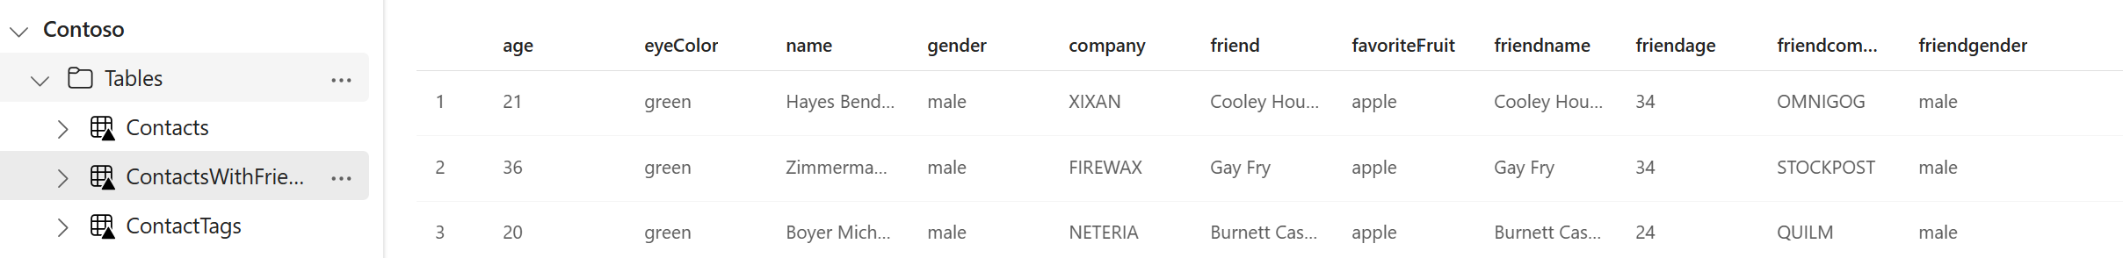

### Task 3: Extract data from OData

In this task, you will extract data from an OData API endpoint: <https://services.odata.org/V4/Northwind/Northwind.svc/>

Create a **Dataflow Gen2** artifact in your workspace.

Click on **Get Data** and choose the **OData** connector.

Define the URL and use the **Anonymous** authentication kind.

Select the table **Invoices** and **Products** and click on Create.

Select the **Products** query, expand the **Category** table by selecting the **CategoryName** column.

Display the execution plan for the **Products** table which contains 2 possible execution plans, one containing the “Expand” predicate to extract the Category Name from the Products entity.

Select the **Invoices** query, then select the Merge queries from the Home ribbon.

Define the **Merge** transformation using the **ProductID** for the **Inner** join and validate.

Expand the created table object **Products** and select the columns **UnitsInStock**, **CategoryName** and **Supplie**r.

Configure the Lakehouse as the query destination, using **Invoices** as table name.

**Publish** the Dataflow.

Explore the **Invoices** table in the Lakehouse.

Wait until the end of the dataflow execution and rename it as **Invoices**.

Open the **Refresh Schedule** option for the **Invoices** dataflow.

Select the **Refresh history** link.

**Refresh history** gives details about the recent dataflow execution.

Configure and **Daily refresh** and click on **Apply**.

